SWEP ServiceNow Implementation – User Guide – Frequency & Off Contract Products.
- Login to the Prescriber portal.
- Choose SWEP/NDIS
- Choose Category of CONTINENCE
- Continue to Picking List
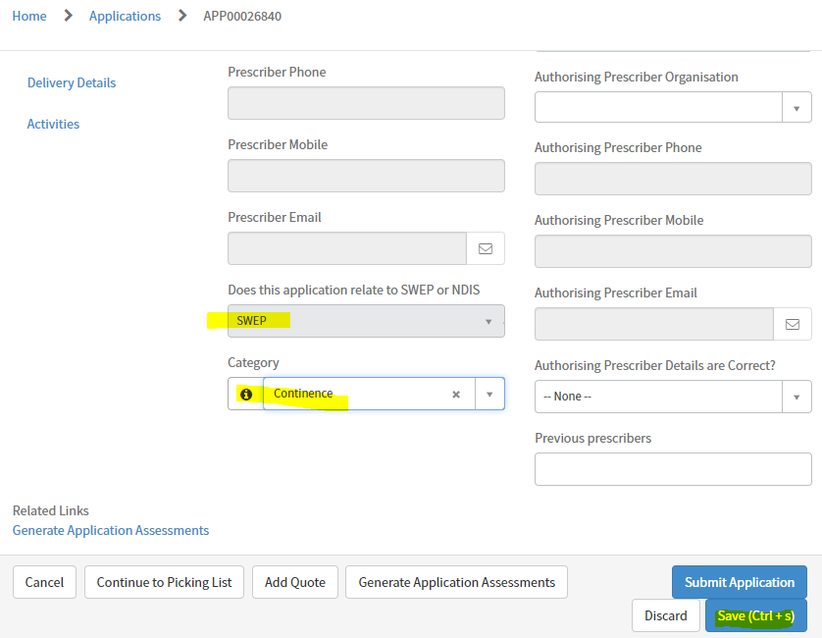
Search function, search with the word “Off”, list results will appear with Off Contract items. Choose item, item quantity, add supplier item number and supplier item description, then click add to cart.
As part of these items for NDIS you will have Frequency of order options of 6 or 12 months to choose.
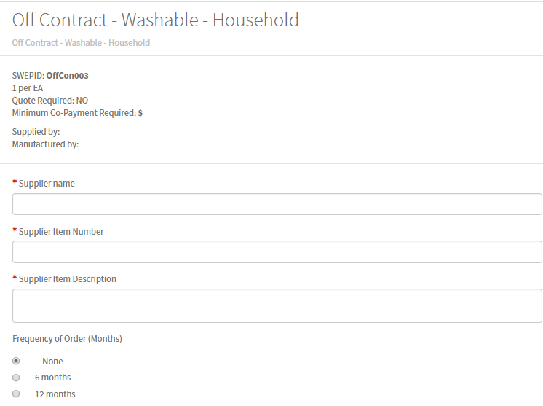
Selected Contracted items will also display the Frequency of Order Option now. If you don’t require these then leave defaulted to “None”.
